SDC Vol 2 No 160 Fol 97-100 Grant to Henry Coryear 18-11-1835
Editorial Note: Much of the text in these grants is boiler plate with the particulars of the piece of land being handwritten in the appropriate places. To distinguish between the boiler plate and the specific details of the transaction, the latter are shown in italics.
L.S. Newfoundland No. 160
H. PRESCOTT
George the Fifth, ^{WILLIAM the Fourth} by the Grace of GOD, of the
Sgd. United Kingdom of Great Britain and
 | Stg.
Great Seal… | 5”
Secretary… | 10”
Surveyor… | 1.4 -
Chainman… | 16.0
 | 2.15.0

Ireland and of the British Dominions beyond
the Seas, King, Defender of the Faith,
Emperor of India
To all to whom these presents shall come Greeting
KNOW Ye that We, of Our Special Grace, Certain Knowledge and Mere
Motion, have given and granted, and by these presents do, for Us, Our Heirs and
Successors, Give and Grant unto Henry Coryear of Cape Broyle in the
Island of Newfoundland, Planter
Cost of Land $
Fee for Grant $
_______
$____
_______
In Our Island of Newfoundland his Heirs and Assigns,
All that piece and parcel of Land situate and being at River Head of Cape Broyle
aforesaid bounded on the North by a Garden on the East by a sea or
harbour of Cape Broyle and on the South and West by ungranted land
- - - - - - - - - - - - - - - - - - - - - - - - - - - - - - - - - - - - - - - - - - - - - - ALSO all that other
piece and parcel of land likewise situate at Cape Broyle aforesaid
bounded on the North by ungranted land on the East partly by uncultivated
land partly by John Walsh’s and Walter Shelley’s land on the South by
abutted and bounded as follows, that is to say, by a line commencing at a point
South Pond and the river running thereinto and on the West by a waste
marsh ALSO all that other piece and parcel of land likewise situate at
Cape Broyle aforesaid and lying between “Fairy Pond” and “North Pond”
bounded on the East by the Beach and on the West and North West by a lane
ALSO all that other piece and parcel of Land likewise situate at Cape
Broyle aforesaid lying South of Fletcher’s Hill bounded thereby on the
North and on the East by Dougherty’s Meadow on the South by the new line of
road from Bay Bulls to Renewse [sic] and on the West by ungranted Land ALSO all
that other that piece and parcel of land likewise situate at Cape Broyle afore-
said and lying on the North bank of the Spout River and bounded on the
North partly by James Haley’s [sic] land and partly by waste land on the East by
the aforesaid river and on the South and West by ungranted land ALSO all that
other piece and parcel of land likewise situate on the North side of the afore-
said River bounded on the North East by a garden on the South East by a road
and on the South West and North West by ungranted land and being of the dimen-
sions specified in the diagram delineated on the other side hereof and num-
bered respectively 1-2-3-4-5 and 6 and containing in the whole Thirteen acres
two roods and one perch with the appurtenances except and reserved nevertheless
And being of the dimensions in the diagram delineated on the other side hereof, and containing

with the appurtenances, except and reserved , nevertheless, out of this present Grant to Us, Our Heirs and Suc-
cessors, all Gold and Silver and all Coals and other Mines and Minerals, in or under the said Piece or Parcel of Land, ^{or either of them}. To have and to hold (except as before excepted) unto the said
Henry Coryear

his Heirs and Assigns for ever ^^{he} the said Henry Coryear – his heirs and assigns

paying unto Us, as price and consideration of the said Land the sum of one pound eight shillings
Dollars Sterling money Cents at the time of the ensealing and delivery hereof.

Provided also
and this present Grant is upon condition that the said Lands shall be holden
upon under and subject to such regulations as may at any time hereafter be made
by Law for the improvement and cultivation of Lands within our said island of
Newfoundland and subject to all regulations as may at any time hereafter be
made by Law for making Roads Sewers Drains Canals Bridges or other Public
Works or Improvements within our said Island of Newfoundland or any part
thereof and for subjecting any Lands therein situate or the owners or occupiers of
such Lands to rates and assessments or other duties or services for the purposes
aforesaid or for any of them. And that the said Henry Coryear

His Heirs and Assigns shall, at all times, peaceably quit and deliver up possession to Us, our Heirs and
Successors, of all such parts of the Lands aforesaid as may be required for the purposes aforesaid, or any of them,
upon receiving such compensation (if any) as by any Law now in force or hereafter to be made in that respect may
be provided. And it is further provided that in case the said

Heirs and Assign shall make default in the performance of any of the provisions or conditions herein
contained, then this Gran shall be null and void, and the Land hereby granted shall revert to Us, Our Heirs and
Successors

Given under the Great Seal of our aforesaid Island of Newfoundland
at St. John’s, in Our said Island, this eighteenth day of
November in the Year of our Lord One Thousand
eight Nine Hundred and Thirty Five and in the
Sixth Year of our Reign.

Witness our trusty and well beloved Henry Prescott Esquire,
Companion of the Most Honourable Order of
the Bath, Our
Governor & Commander-in-Chief in and over Our said Island of
Newfoundland and its Dependencies, &c.

By His Excellency’s Command,
Sgd. J. Templeman
Colonial ^{Acting} Secretary
Received, the day and year above written, from the within-named Grantee, the sum of
One Pound Eight Shillings
amount of the Consideration Money of the Land herein granted and of the fee for the Grant.

$___________
Registered Volume No. 90 Folio 71
Sgd. J. Templeman
Acting Secretary
Minister of Agriculture and Mines
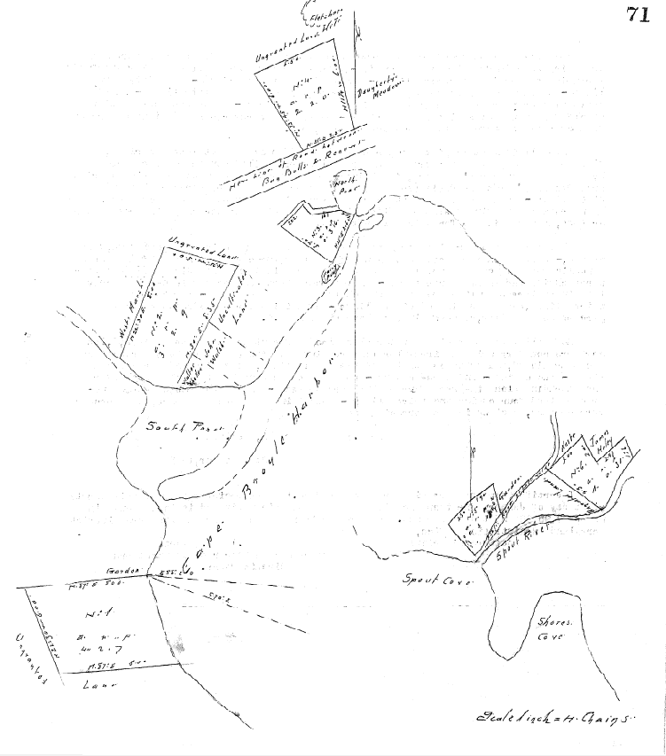
Henry Coryear of Cape Broyle, Planter
Lot No. 160. All that piece or parcel of land situate and being at River Head from the
North East corner of which Spout Cove bears South eighty five degrees East and “Sheep’s
Head” South seventy degrees West abutted and bounded as follows, that is to say:- on the
North by a garden and ungranted land eight chains - on the North East by Cape Broyle Harbor
six chains - on the South by ungranted land eight chains, and on the South West also by
ungranted land six chains – Containing four acres two roods and seven perches more or less
as shown in the above diagram Number 1.

ALSO all that other piece or parcel of land situate at River Head before mentioned
in Cape Broyle, bounded on the North East by ungranted land, five chains - on the South East
partly by uncultivated land and partly by land in the possession of John Walsh and Walter
Shelley, extending along the same eight chains and thirty five links more or less to South
Pond - on the South West by the main River four chains – and on the North West by a waste
marsh eight chains - containing three acres two roods and nine perches more or less as
shown in the above diagram N.2.

ALSO all that other piece or parcel of land situate and being between North Pond
and Fairy Pond in Cape Broyle aforesaid - bounded on the North East by an irregular line
measuring one chain and twelve links – one chain and ninety links – and sixty five
links – on the South East by Cape Broyle Harbor, two chains and ninety links – on the
South West by ungranted land, three chains and eighty links - and on the South West by
a foot path two chains and two links - containing three roods and sixteen perches
more or less as shown in the foregoing Diagram, No.3.

ALSO all that other piece or parcel of land adjacent to that last described,
situate and being between “North Pond” and “Fletcher’s Hill” bounded on the North east
by “Dougherty’s Meadow”, six chains - on the South East by the new line of road
from Renews towards Bay Bulls ( to be kept one hundred feet wide) three chains and
fifty links - on the South West by ungranted land six chains and on the North West also
by ungranted land five chains and fifty links – containing two acres two roods more
or less, as shown in the foregoing Diagram No.4.

ALSO all that piece or parcel of land situate and being at Spout Cove Cape
Broyle - bounded on the North East by ungranted land, two chains - on the South East by
a public road (to be kept not less than twenty feet wide) and extending along the same
three chains and twenty three links - on the South West and North West by high rocky
land in an irregular line measuring two chains and seventy links – two chains and
thirty links and one chain and ninety links – containing three roods and eighteen
perches more or less, as shown in the above diagram No.5.

ALSO all that other piece or parcel of land adjacent to that last described, its
northern boundary being an irregular line running from “Spout River” to the road last
above mentioned, measuring one chain and twenty six links, two chains and forty seven
links – two chains – and three chains - bounded in the South East by the said river
and extending along the same four chains more or less - and on the South West by un-
granted Land four chains and thirty – containing one acre and thirty one perches
more or less, as shown in the foregoing Diagram No.6.

(Sgd.) John Noad Sur. Genl.

I certify that the foregoing Grant of Land No. 160 was registered by me this twenty
eight day of January one thousand eight hundred and thirty six and is to be found in
pages 97, 98, 99 and 100 of the 2nd. Volume of Registry of Deeds for the Southern District
Ferryland (Registration Office,
Southern District) (Sgd.) A. Hogsett
Clerk and Registrar of the Southern
Circuit Court.

There is an asterisk placed here which refers to a marginal note written sidewise on the left: Provided always and this present grant is upon condition that the same grant be registered in the Office of Registry of our Southern District Court of Newfoundland within Six months next after the day of the date hereof or otherwise that the same shall be void and of non effect.

