SDC Vol 2 No 727 Folio 367-370 Grant to Elizabeth Carter Eliza Woolcombe Robert Carter James Howe Carter 19-06-1848
Editorial Note: Much of the text in these grants is boiler plate with the particulars of the piece of land being handwritten in the appropriate places. To distinguish between the boiler plate and the specific details of the transaction the latter are shown in italics.
J. Gaspard Le Marchant
{L.S.}
No. 727
Newfoundland
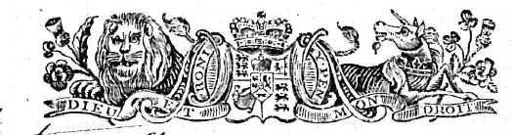

WILLIAM the Fourth ^^{Victoria} by the
Grace of GOD of the United Kingdom of Great
Fees | Stg.
Great Seal
Secretary
Surveyor
Dep^{y} Surveyor

Britain and Ireland King [sic] Defender of the Faith

To all to whom these presents shall come Greeting

KNOW ye that WE of our special grace
certain knowledge and mere motion have given and granted and by these Presents
do for Us our heirs and successors Give and Grant unto Elizabeth Carter, Eliza
Woolcombe of Exeter England and Robert Carter, James
Howe Carter of Ferryland Heirs to the estate of the late
Robert Carter

____ [sic] heirs and assigns all that piece and parcel of Land situate and being
to the South West of the Main Road leading to Ferryland Head
and upon the North West side of Coleman’s lane known and dis-
tinguished as Pool Field abutted and bounded as follows, that is to say,
by a line commencing at a point on the North side of the said lane at the
South east angle of land belonging to the estate of the late Rich^{d.} Nason
then bounden by the said land and extending thereby in a South westerly
direction Two chains and fifteen links more or less thence bounden by
land in the possession of William Coleman and running by the magnet in 1847 North sixty three degrees West
two chains and fifty six links thence North thirty three degrees thirty minutes East seventy five links thence bounden
by land occupied by William Saunders and running North westerly Twenty eight links thence north forty two
degrees East eighty seven links thence north Twenty one degrees thirty minutes East fifty five links
bounded by the before named estate of the late Richard Nason and running Southeasterly on a Straight line Two
chains and sixty five links more or less to the Place of commencement containing Two Roods
and twelve Perches more or less as shown in the Diagram Nº 1 on the other side hereof
Also all that other Piece or Parcel of Land situate and being on the North East side of a Public
Road leading to Ferryland Point, abutted and bounded as follows, that is to say, on the North by a shore
of Water known as the Pool extending thereby one chain and twenty one links on the Eastward by
land belonging to the estate of Richard Nason one chain and twenty two links on the South West
by the Road above named one chain and Sixty one links and on the North Westward by the estate
of the late William Carter in irregular lines measuring respectively seventy five links, twenty
three links and Sixty five links containing Twenty nine Perches more or less as shown in
the diagram Nº 2 on the other side hereof, and being of the dimensions specified
in the diagram delineated on the other side hereof.

in our Island of Newfoundland bounded as the same is delineated and described
in
in the diagram hereunto annexed and containing in the whole Three Roods and
One Perch more or less.

with the appurtenances except and reserved nevertheless out of this present
Grant to Us our heirs and successors all Gold and Silver and all Coals and other
Mines and Minerals in or under the said piece or parcel of Land.
To Have and to Hold (except as before excepted) unto the said Elizabeth Carter
Eliza Woolcombe Robert Carter and James Howe Carter

___ [sic] heirs and assigns for ever they the said Elizabeth Carter, Eliza Woolcombe Robert Carter
and James Howe Carter paying onto us as the price and consideration of the
said land the sum of five shillings Sterling money at the time of the ensealing
and delivery hereof.

heirs and assigns yielding and paying therefore yearly and every year
for ever unto Us our heirs and successors at the Office of the Secretary of our Go-
E. M. Archibald
H. M. Atty. Genr.

vernor of our said Island for the time being in the Town of St. John’s in our
said Island of Newfoundland or to such other person as shall be appointed to
receive the same the yearly Rent or Sum of
Sterling Money of our said United
Kingdom for each and every Acre of the said Land hereby granted to
commence on the 24th day of June which shall be next after the expiration of
Two Years from the day of the date hereof and to be paid yearly and every year
on the 24th day of June for ever. And in default of the said payment or if it shall
happen that the aforesaid yearly Rent shall be at any time behind and unpaid in
the whole or in part by the space of Thirty Days next after any day whereon the
same ought to be paid as aforesaid then and from thenceforth this Grant shall
immediately cease and determine and be void and of non effect and the said Land
and Appurtenances shall revert to and revest in Us our heirs and successors.
Provided always that and this Grant is upon condition that
part or portion of the Land hereby granted shall be properly cleared cleansed
and cultivated within the period of Three Years next ensuing after the day on
which Rent shall first become due and payable under the provisions of this Grant.
Provided also and this present Grant is upon condition that the same Grant
be registered in the Office of Registry of our Southern District Court of
Newfoundland within Three ^{Six} months next after the day of the date hereof
or otherwise that the same shall be void and of non effect. Provided also
and this present Grant is upon condition that the said Lands shall be holden
upon under and subject to such regulations as may at any time hereafter be made
by Law for the improvement and cultivation of Lands within our said island of
Newfoundland and subject to all regulations as may at any time hereafter be
made by Law for making Roads Sewers Drains Canals Bridges or other Public
Works or Improvements within our said Island of Newfoundland or any part
thereof and for subjecting any Lands therein situate or the owners or occupiers of
such Lands to rates and assessments or other duties or services for the purposes
aforesaid or for any of them. And that the said Elizabeth Carter, Eliza Woolcombe Robert Carter
& James Howe Carter their heirs and assigns shall at all times
peaceably quit and deliver up possession to Us our heirs and successors of all such
parts of the Lands aforesaid as may be required for the purposes aforesaid or any
of
of them upon receiving such compensation (if any) as by any Law hereafter to
be made in that respect may be provided.

Given under the Great Seal of our Island of Newfoundland
at St. John’s this Nineteenth day of June
in the Year of our Lord One Thousand Eight Hundred and
Forty Thirty Eight [sic] and in the Eleventh Year of our Reign.

Witness our trusty and well beloved Sir John Gaspard
Le Marchant Knight and Knight Commander of the orders of Saint
Ferdinand and of Charles the third of Spain our Governor and Commander in Chief
in and over our said Island and its Dependencies &c.

By His Excellency’s Command
Ja^{s.} Crowdy
Received the day and year above written from the within named Grantees
the sum of Five shillings being the full amount of the consideration
money herein mentioned.
Ja^{s.} Crowdy
£0.5.0 Secretary

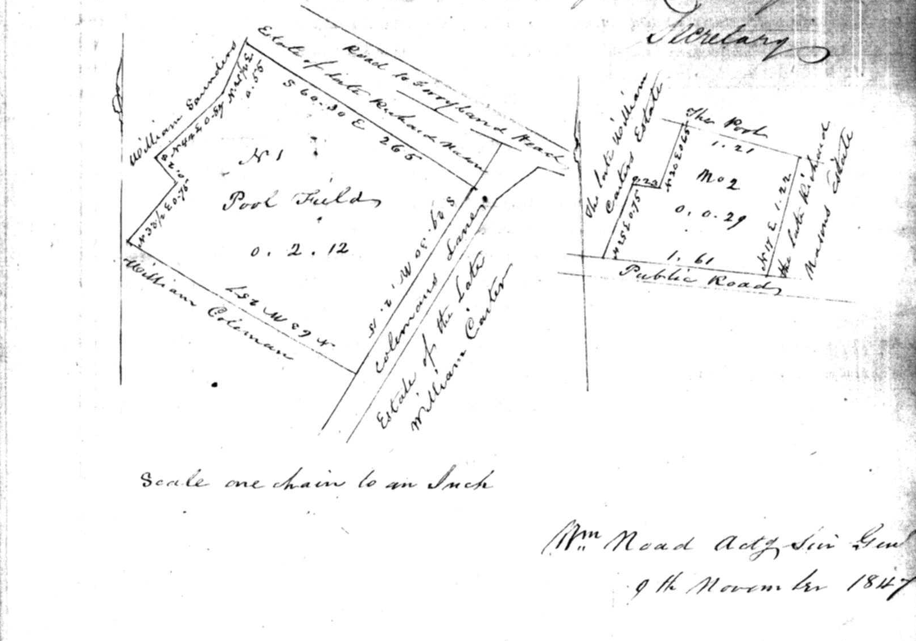

I do hereby Certify that the foregoing Grant of Land
No 727 to Elizabeth Carter, Eliza Woolcombe of Exeter England Robert Carter
and James Howe Carter of Ferryland was duly registered this Eighth
day of December AD one thousand eight hundred & Forty Eight.

George Simms
Registrar

